**COMPUTER NETWORKS**

**NAME: M.ISTAFA MALIK**

**ROLL: P190033**

**SECTION: BSCS-5A**

**Task**: **How to configure an FTP server in Packet Tracer and also how to create a file in the Laptop then upload it to the server using FTP and http, also upload html file and try accessing it using web browser from PC.**

**Solution:**

**Step 1: Topology**

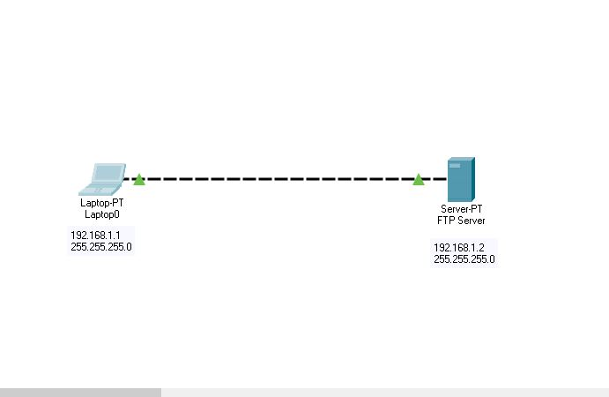

**Step 2:** Assign Static IP’s

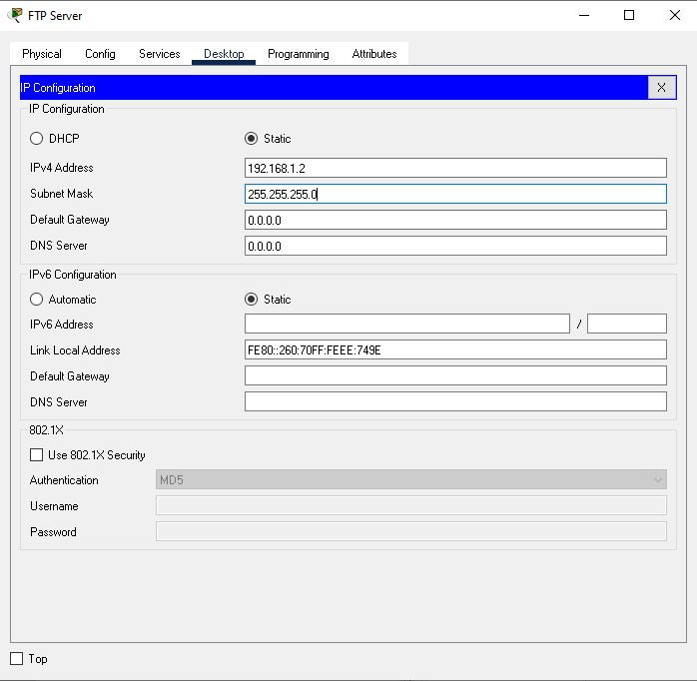

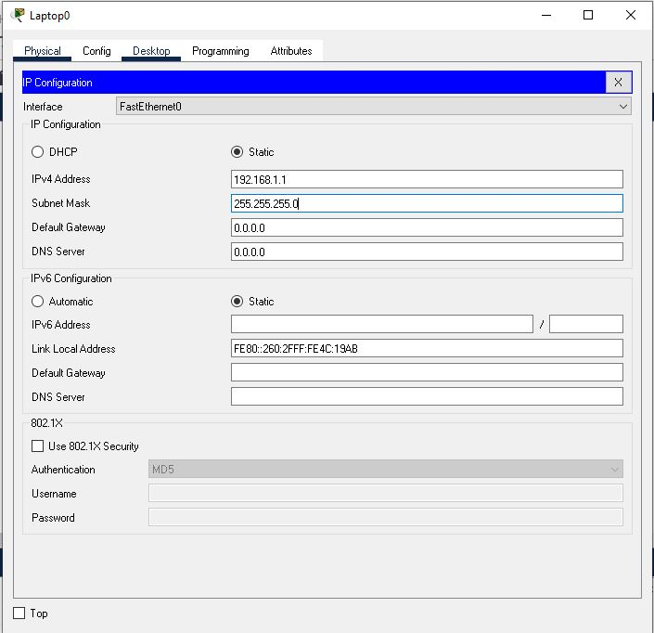

**Step 3:** Now From the Laptop’s command prompt, FTP the server using the following command:

ftp 192.168.1.2

Provide the username (cisco) and password (cisco) that are default.

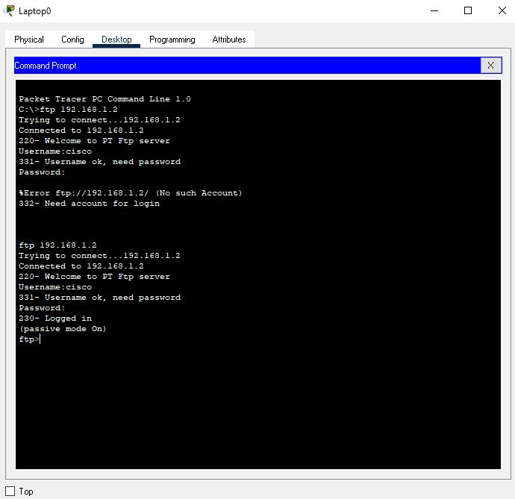

**Step 4:** Now create a file by opening the Text Editor in the Laptop, create a file and give it your name of choice. Type any text in the editor then save your file. e.g. myFile.txt.

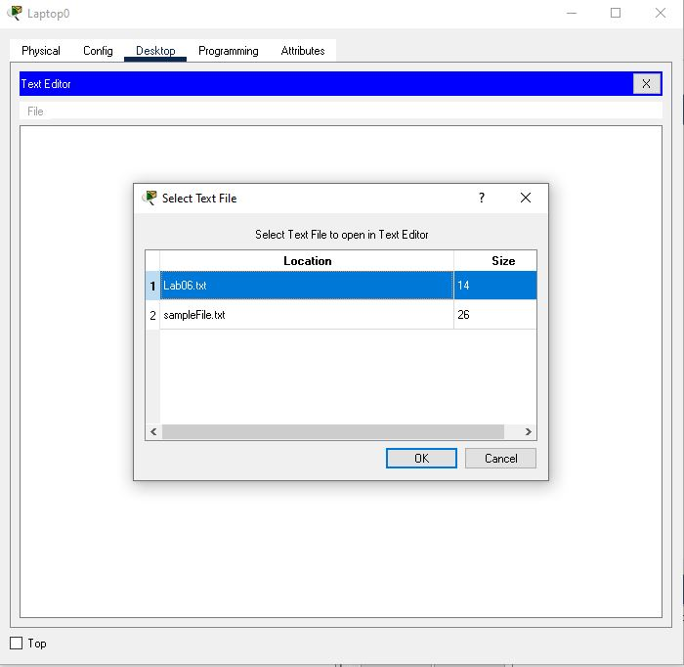

**Step 5**: Use following command to transfer file ftp server.

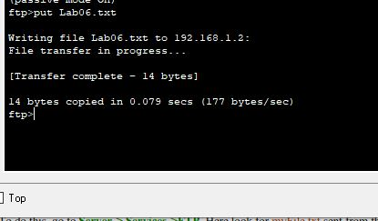

**Step 6**: Now use http

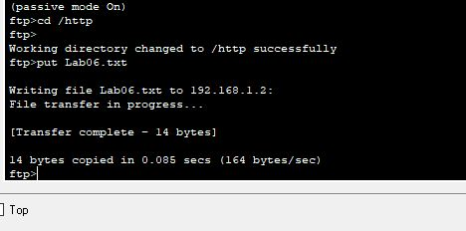

**Step 7:** We’ll create an html file in our Laptop, upload it to HTTP server directory using FTP, then try to access the file from the Laptop’s browser.

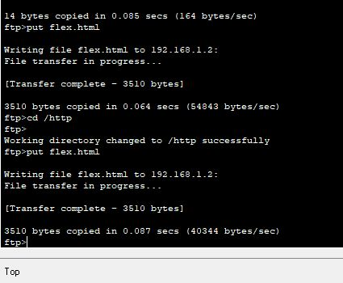

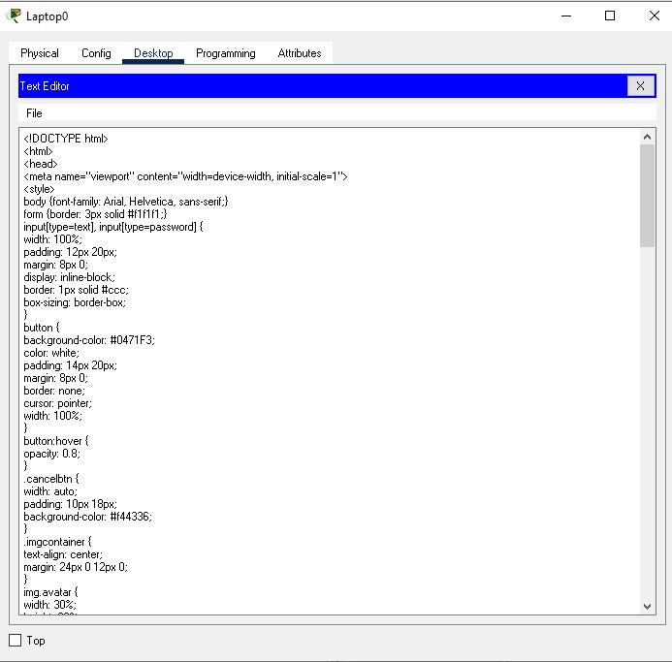

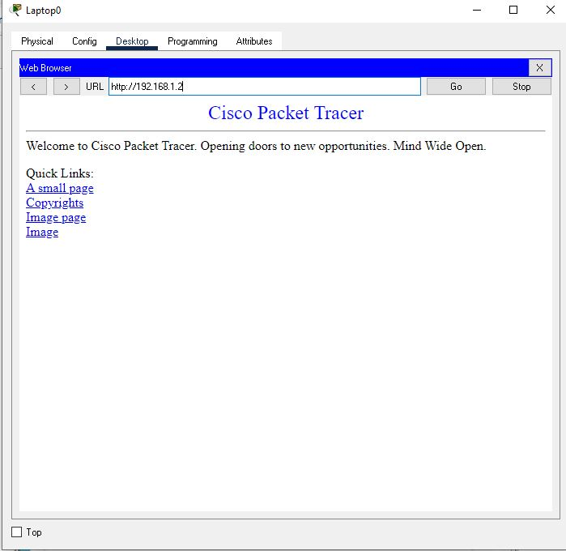

**Success!!!!!!!!!!!!!!!!!!!!!!!!!!!!**

**Task:**

1. Configure an email server in Packet Tracer
2. Configure an FTP server in Packet Tracer
3. Create and Upload html file to HTTP server directory Using FTP
4. Configure Mail server, Ftp Server, DHCP Server, DNS Server and web Server in a single topology, use router and switch.

**Solution:**

Step 1: Topology

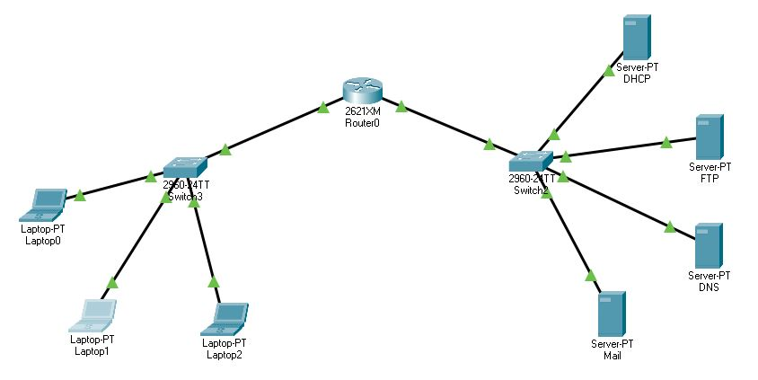

Step 2: Router Configuration

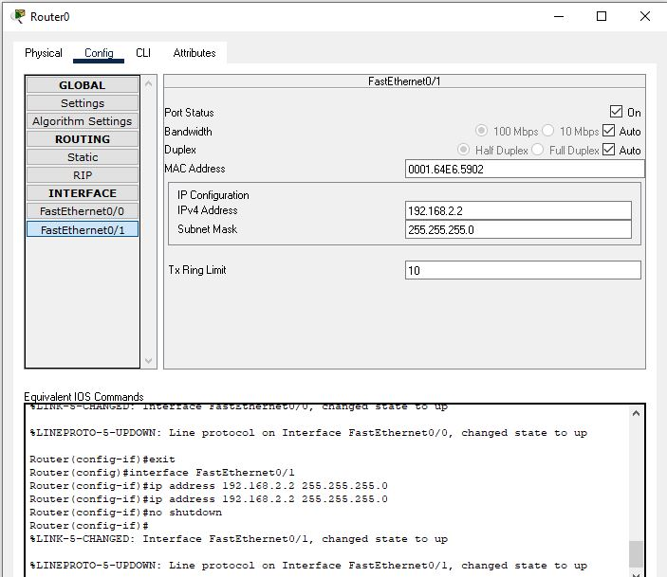

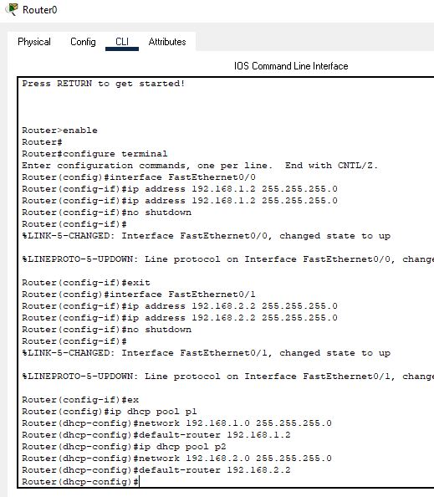

Step 3: DHCP Configuration

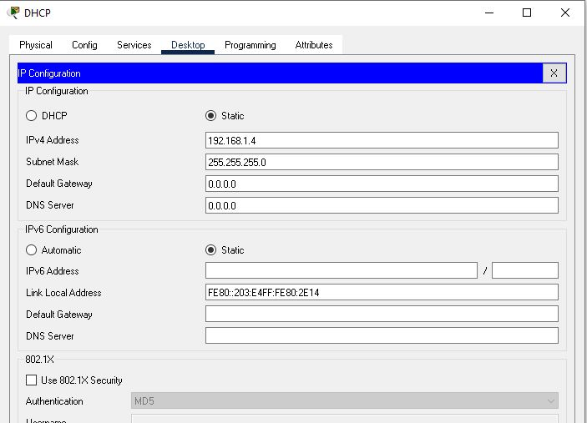

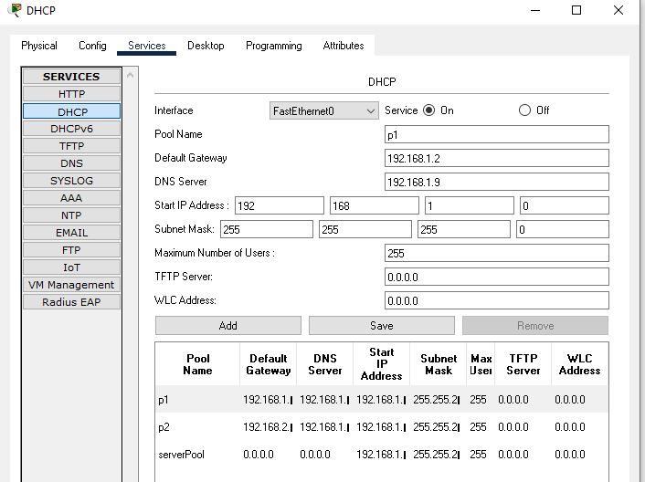

Step 4: DNS configuration

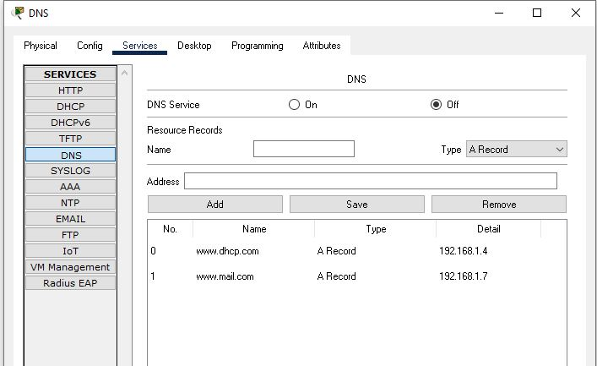

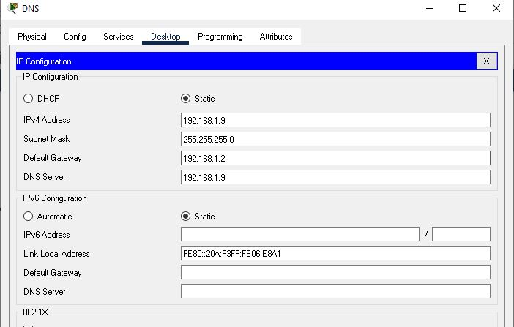

Step 5: FTP Configuration

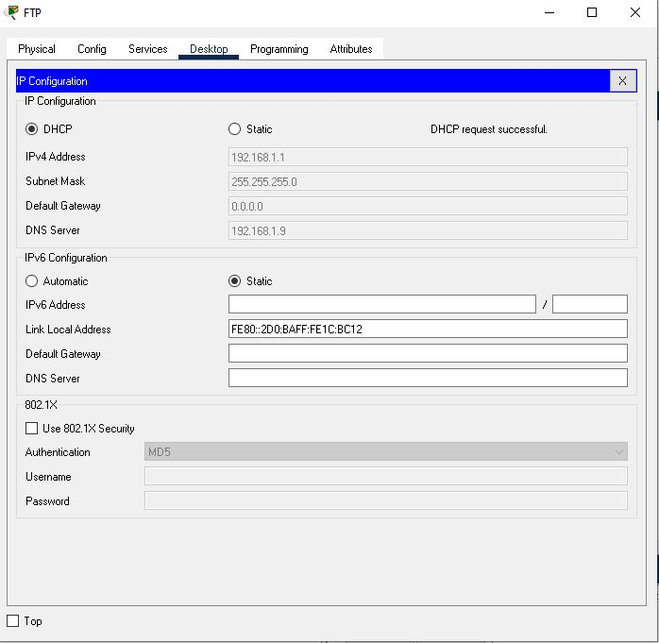

Step 6: Try assigning IP’s to Laptops using DHCP

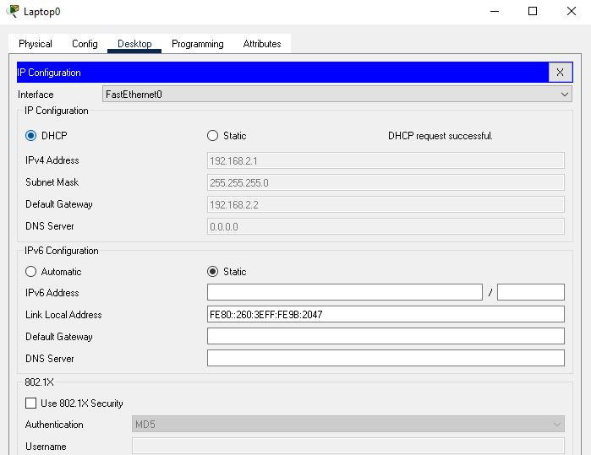

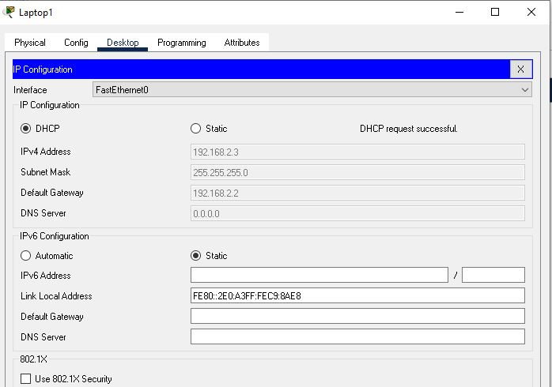

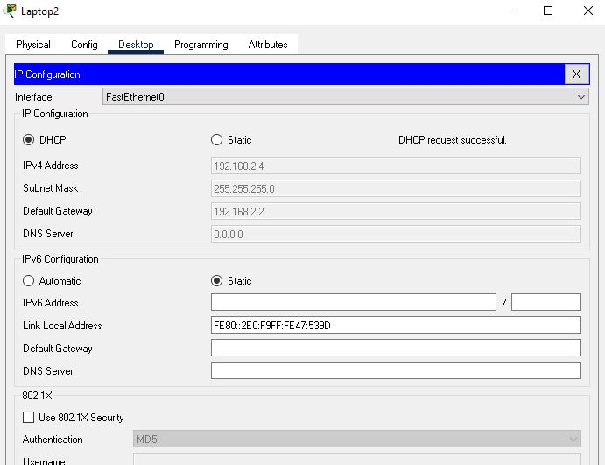

Step 7: Configure Mail Server

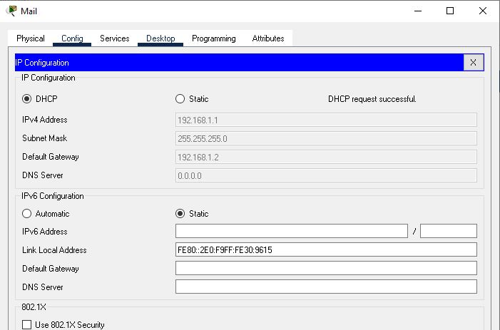

Step 8: